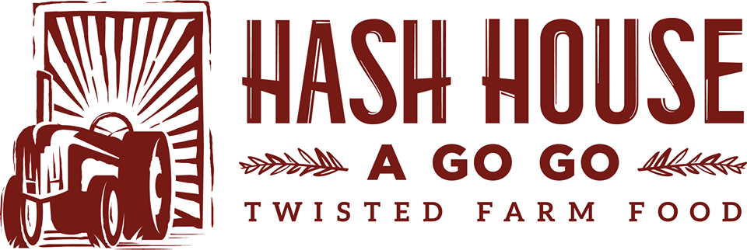
With
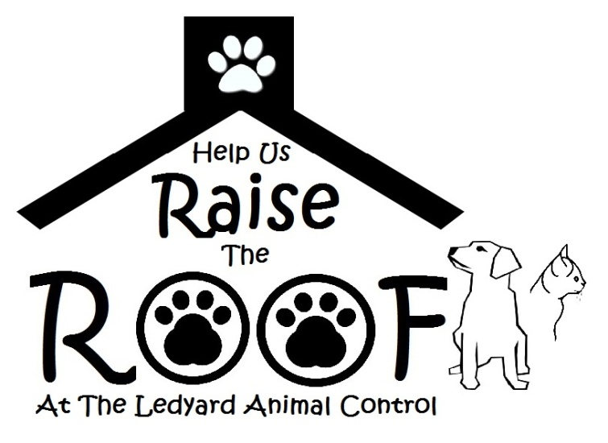
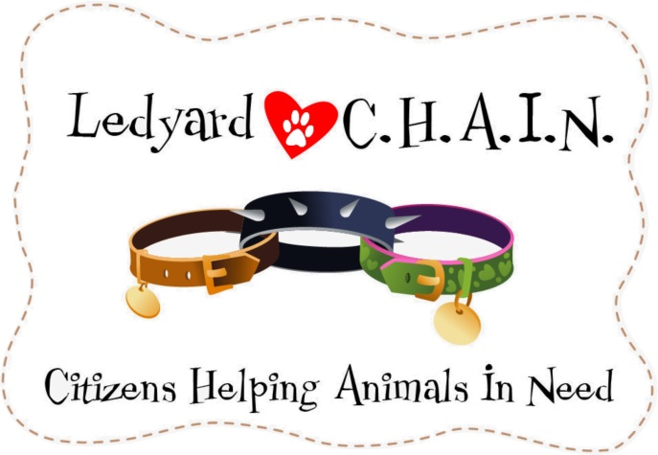

Come out on April 4th from 6pm-10pm to Hash House inside Mohegan Sun to benefit Ledyard C.H.A.I.N. and help raise money for a new roof at the Ledyard Animal Control

Here’s how it works: bring this letter to Hash House a Go Go @ Mohegan Sun, and we will donate 20% of your sales receipt to “Ledyard C.H.A.I.N” for the Raise the Roof Fund for a new roof for the Ledyard Animal Control

The more you spend, the more funds we can raise for this great cause. Come out in support of your community, enjoy the best food in under the sun and let’s Raise the Roof, together!

